Configuring DwgToPDF Conversion Tool to Share Point

Purpose: This document provides how to configure a Custom Tool developed by Processive Solutions for its client Cona Resources Ltd.
Environment Pre-requisite:

- Any DWG to PDF Converter Pro (11802-6)
  - This software is required to convert an AutoCAD produced drawing files (dwg files) to PDF. This software must be installed on at least one Web Front End Server.
- An account that will be used to run above tool using Power Shell Script, this account will also be used as to login into Share Point to use in updating Share Point List Items such as AuditLogs. This account should also have permissions to create, edit and delete files on all Paths as configured in Config SharePoint List. This account will also be used to create a Windows auto schedule task that would keep Power shell script to poll for new drawing files to convert them in to PDF.

Configuration Details:
Log into Web Front End and configure following:
Share Point specifics:
- Use Config List Template (Config_List_Template.stp) to create SharePoint Config List.
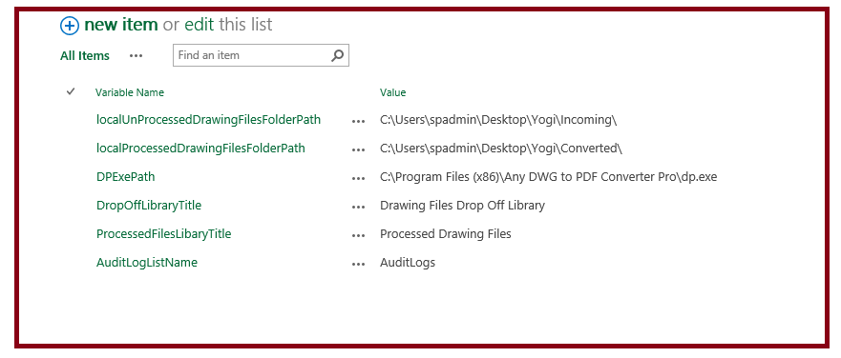
- The Config list governs the behavior of the tool and it should be set properly for tool to run smoothly. The following table provides more details. The Variable Names should not be changed as they are being used in code. Only pre set Value can be changed as per Target Environment.

Variable Name | Purpose | Value (Pre Defined)
localUnProcessedDrawingFilesFolderPath | This variable is set to a path on the WFE where Any DWG to PDF Converter Pro (11802-6) tool is installed. The path is used to copy new Drawing Files from SharePoint’s Pre configured Library (This Library’s Title can be configured in Variable Name: DropOffLibraryTitle) to this location. | C:\Users\spadmin\Desktop\Yogi\Incoming\
localProcessedDrawingFilesFolderPath | This variable is set to a path on the WFE where Any DWG to PDF Converter Pro (11802-6) tool is installed. The path is used to copy converted PDF Files before uploading to SharePoint’s Pre configured Target Library (This Library’s Title can be configured in Variable Name: ProcessedFilesLibaryTitle) to this location. | C:\Users\spadmin\Desktop\Yogi\Converted\
DPExePath | This variable is set to the path on the WFE where Any DWG to PDF Converter Pro (11802-6) tool is installed. | C:\Program Files (x86)\Any DWG to PDF Converter Pro\dp.exe
DropOffLibraryTitle | The SharePoint Library’s Title that will be used to process Drawing Files. | Drawing Files Drop Off Library
ProcessedFilesLibaryTitle | The SharePoint Library’s Title that will be used to copy converted PDF Files. | Processed Drawing Files
AuditLogListName | The SharePoint List’s Name that will be used to write Audit Log. | AuditLogs

- (Optional) Use Drawing_Files_Drop_Off_Library_Template.stp and Processed_Drawing_Files_Library_Template.stp to create “Drawing Files Drop Off Library” and “Processed Drawing Files” Libraries.
- Use AuditLogs_List_Template.stp, to create AuditLogs SharePoint List.
- File Explorer (on Web Front End Server that has Any DWG to PDF Converter Pro tool installed.
  - Create a Local Folder and copy Dwg2PdfConverterTool.ps1 from Git Repository
  - Create two sub folders and set their path to following two variables in SharePoint’ Config List as per above table.
    - localUnProcessedDrawingFilesFolderPath
    - localProcessedDrawingFilesFolderPath
- Create a Windows Auto Schedule Task to Run Dwg2PdfConverterTool.ps1 on a scheduled basis.
  - Open Task Scheduler by tying Task Scheduler on Windows Server Search box or by navigating from Administrative Tools
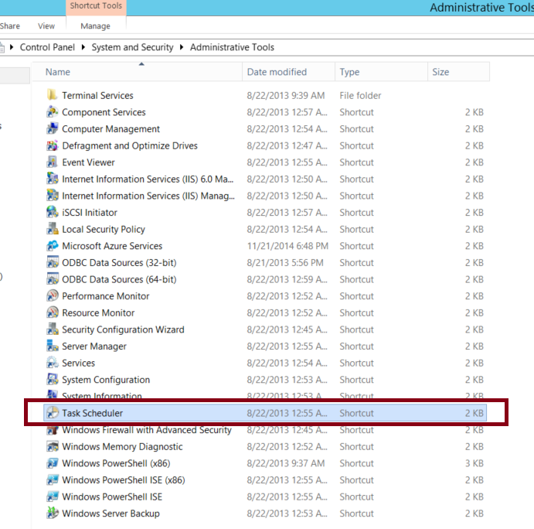
  - Click on “Task Scheduler” and click on “Create Task…”
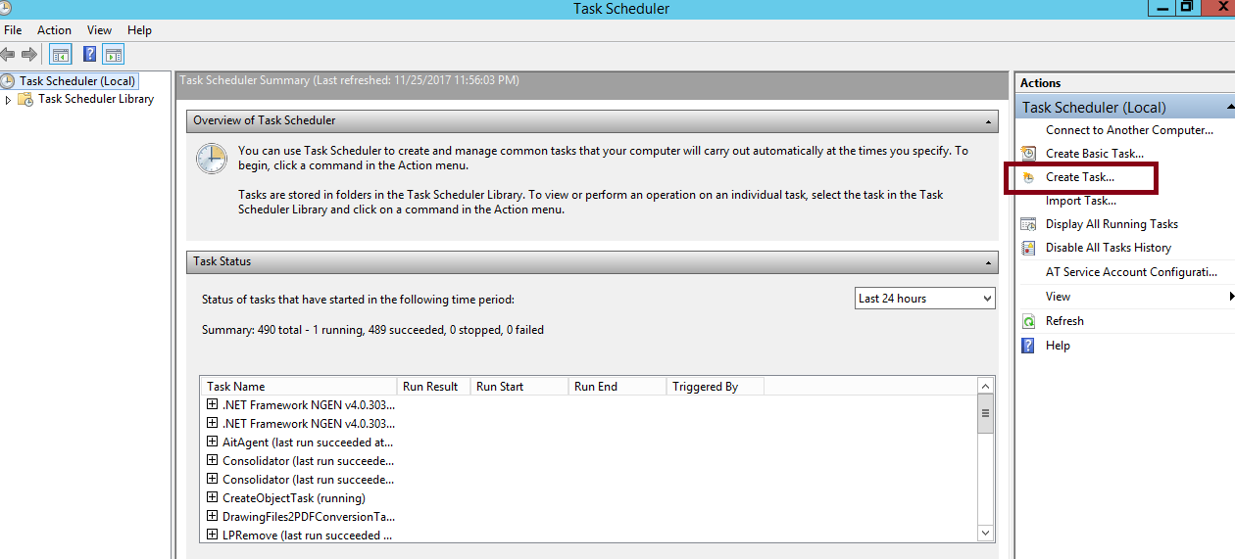
  - Create a Task as per following details:
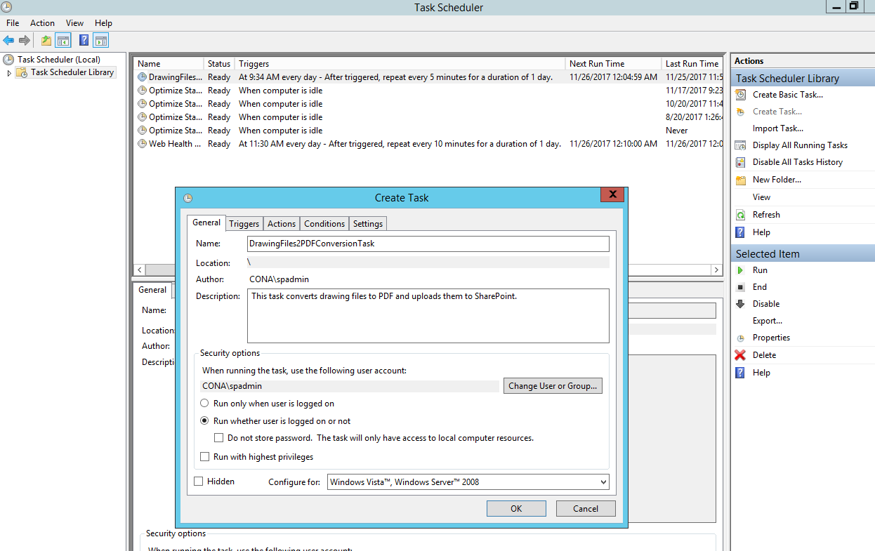
  - Create a schedule as per following:
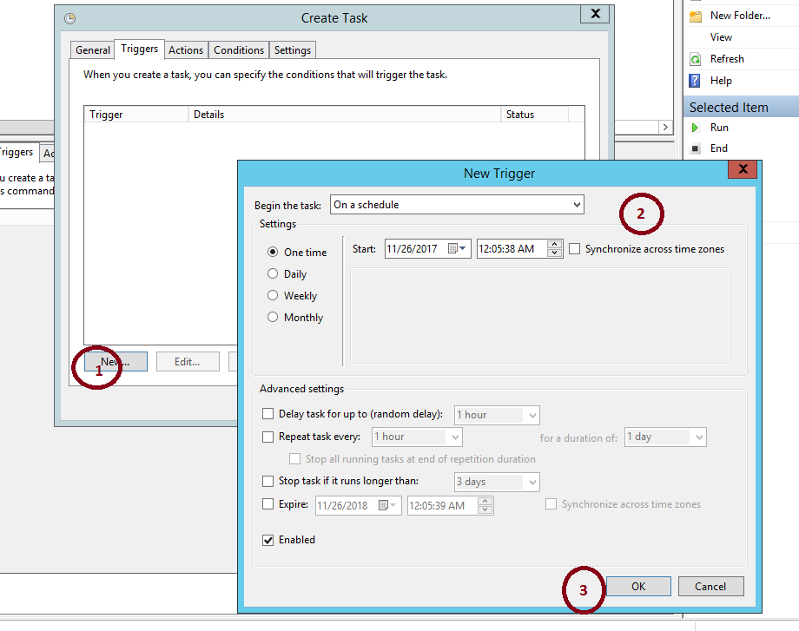
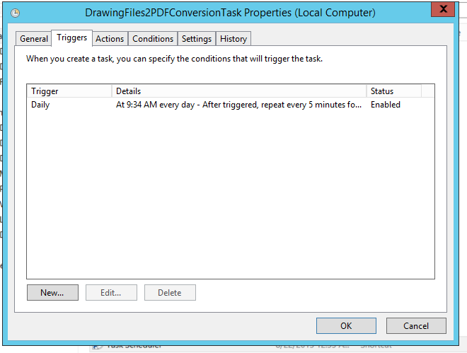
  - On the Actions tab and click New to set the action for this task to run.
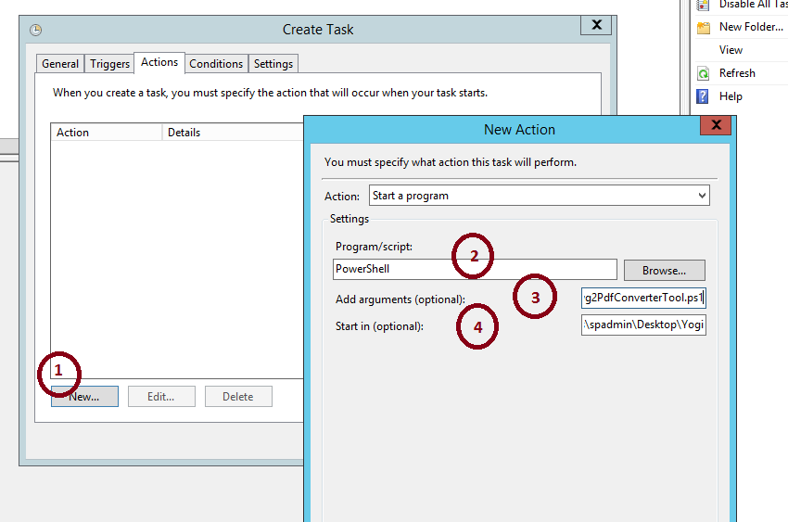

    - Set the Action to Start a program.
    - Program/script box enter "PowerShell."
    - Add arguments (optional) box enter the value “.\Dwg2PdfConverterTool.ps1”
    - Start in (optional) box, add the location of the folder that contains the PowerShell script, for example: “C:\Users\spadmin\Desktop\Yogi”

    - Click OK.
  - Click OK on Parent Window.

